Personal Website

Learning Evidence-

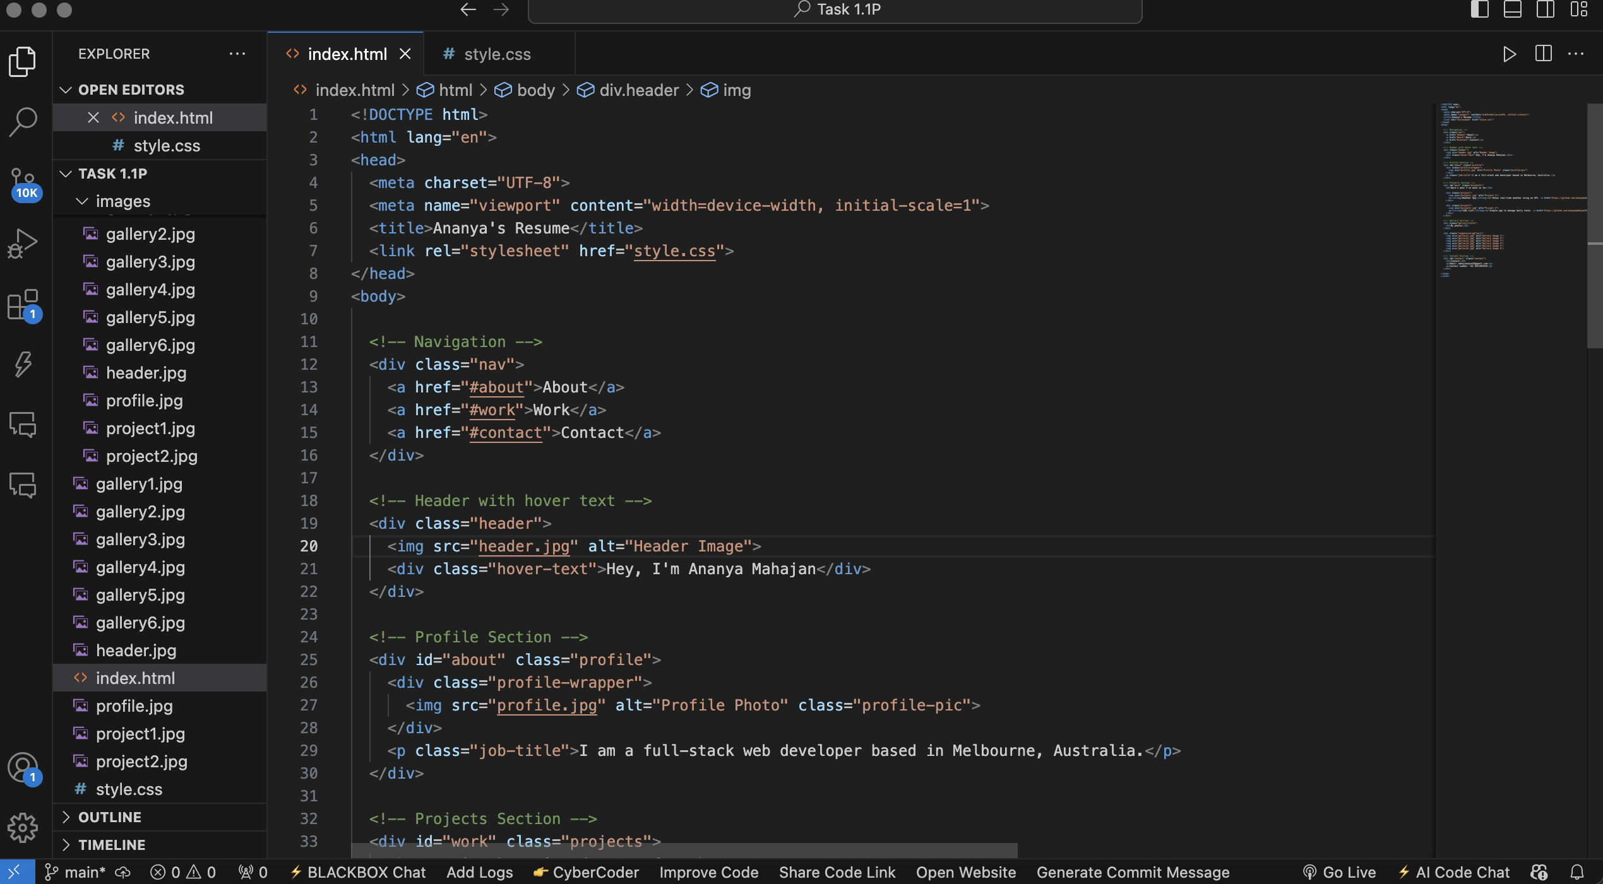

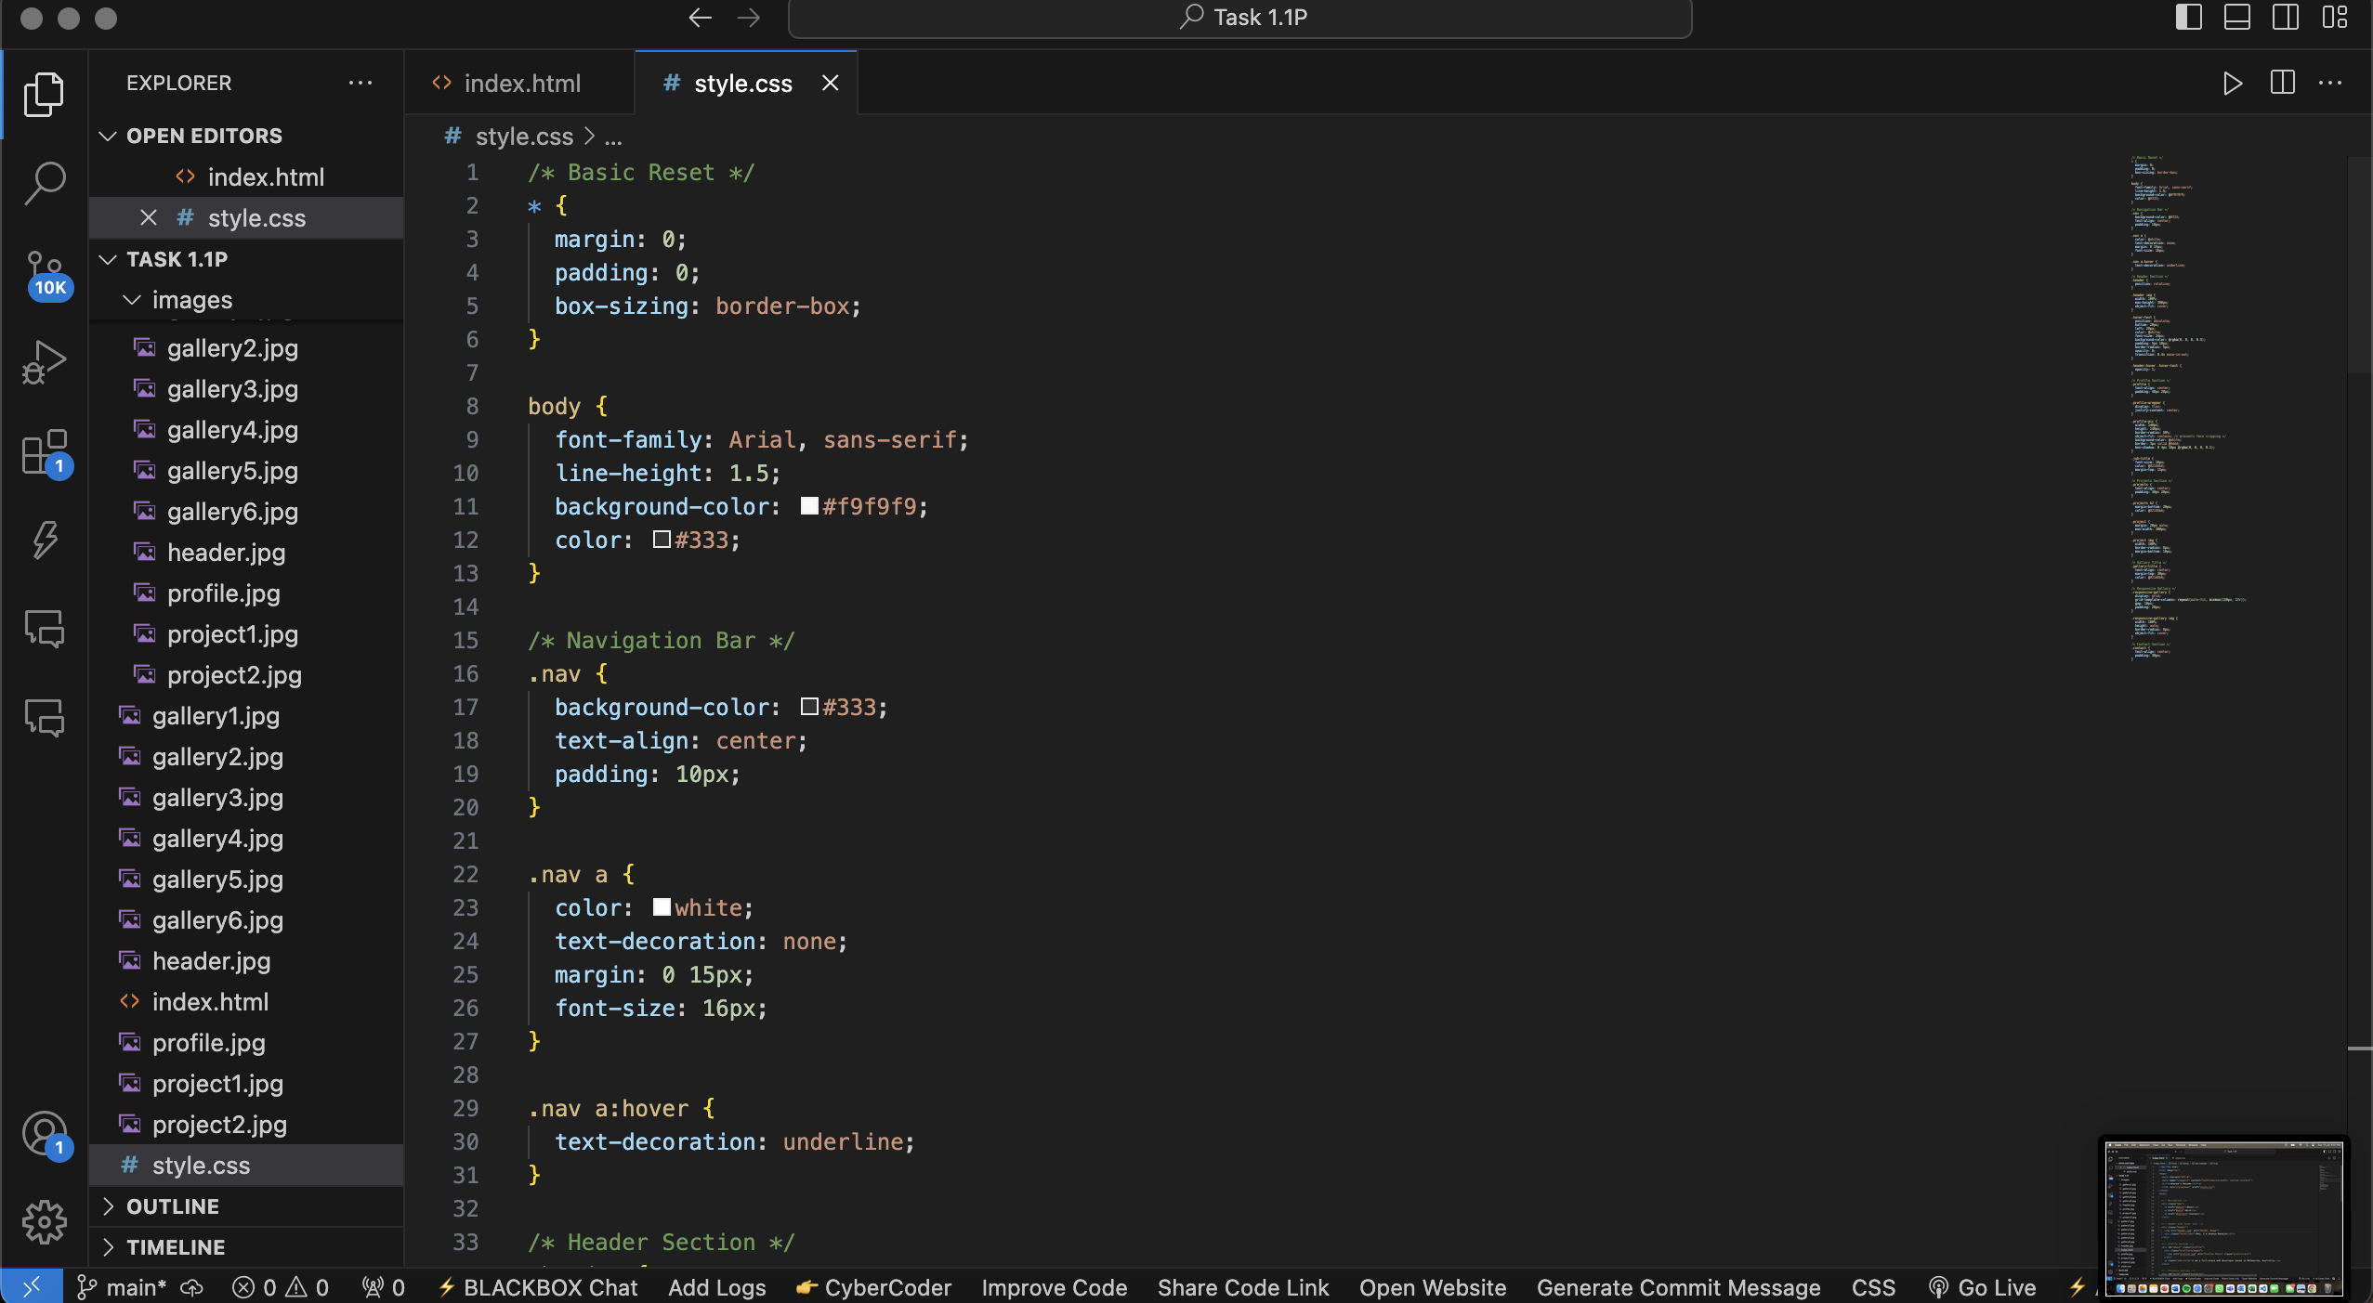

I gained a better understanding of how HTML and CSS interact to produce a well-structured and aesthetically pleasing webpage by designing my own website from the ground up. I gained knowledge about how to style components like navigation bars, picture galleries, and profile sections as well as how to create responsive layouts with grid systems. Additionally, I gained confidence in using hover effects to add more interactivity to the website, linking parts, and integrating connections to GitHub projects. Making sure that photos are properly aligned and suited for various screen sizes was one of the main lessons learned. My inventiveness and attention to detail were enhanced by this project, particularly around striking a balance between design and content.

Links for the Githubs-

<https://github.com/ananyamahajan25/project2.git>

<https://github.com/ananyamahajan25/project1.git>